**Welcome to My Classroom Speech**

**1.Good morning class, my name is Sqalwesihle Ndlovu and I am 6 years old and I am special because I know how to draw, dance and read.**

**2. My school's name is Spark School, and I am in the Crocodiles class. In the classroom, my desk is in the middle, and I love that it is there.**

**3. There are many rules in my class such as raise your hand before you speak, I don’t mind having rules in my class because it teaches us discipline.**

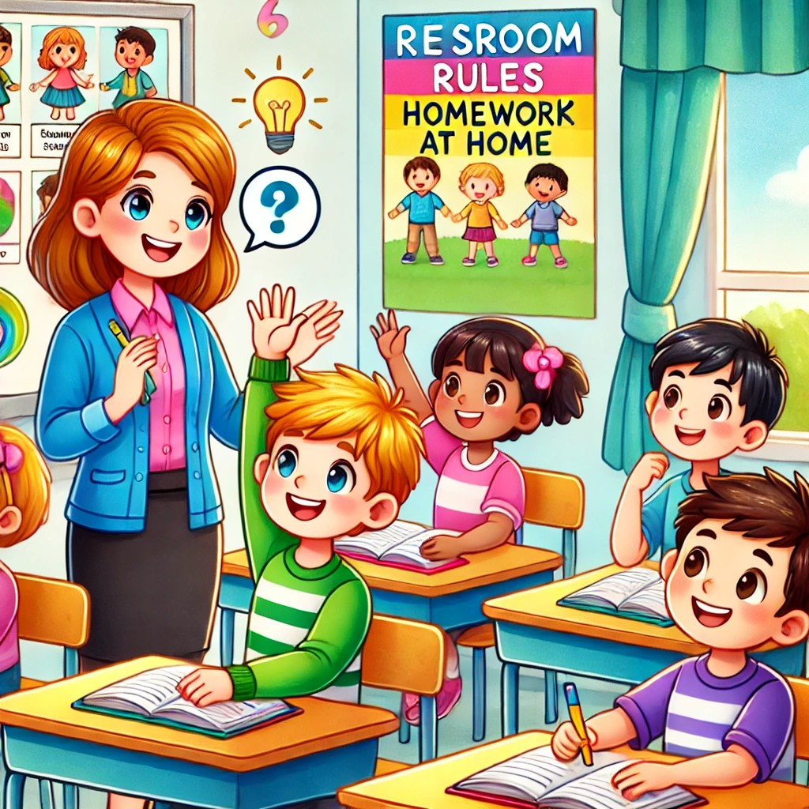

**4.** **The responsibilities I have is to do my homework, to work in class and listen to my teacher.**



**Thank you for listening to my speech.**